ASSIGNMENT 8
Q.1 Assume each salesperson has a 12% commision. Write a query on the orders table that will produce the order number , the salesperson number, and the amount of the salesperson’s commision for that order.
Ans. SELECT Onum, Snum, Amt*0.12 Comm FROM ORDERS;

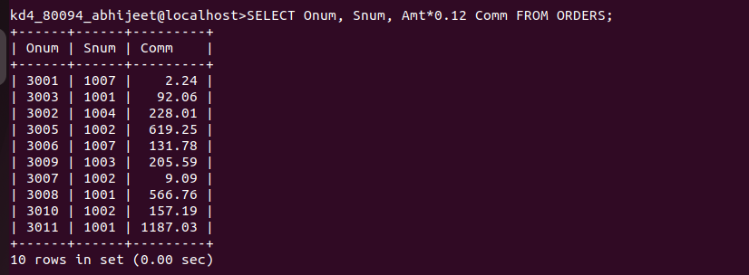

Q.2 Write a query on the Customers table that will find the highest rating in each city. Put the output in this form:
For the city (city), the highest rating is : (rating).
Ans.
SELECT CONCAT(City,' is the highest rating is: ',MAX(Rating)) AS HIGHEST_RATING FROM CUSTOMERS GROUP BY City;

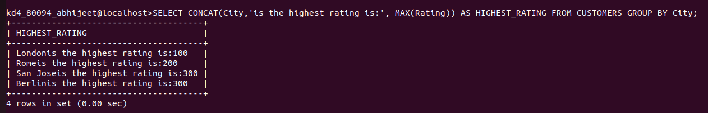

Q.3 Write a query that lists customers in descending order of rating. Output the rating field first, followed b the customer,s name and number.
Ans.
SELECT Rating, Cname, Cnum FROM CUSTOMERS ORDER BY Rating desc;

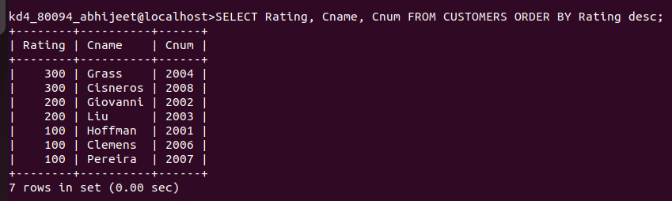

Q.4 Write a query that totals the orders for each day and places the results in descending order.
Ans.
SELECT COUNT(*) as TOTALS FROM ORDERS GROUP BY Odate ORDER BY 1 desc;

